1. **Getting Started**

**Installing Python**

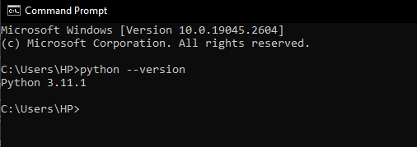

1. **Variables and Simple Data Types**

**Variables**



**Strings**

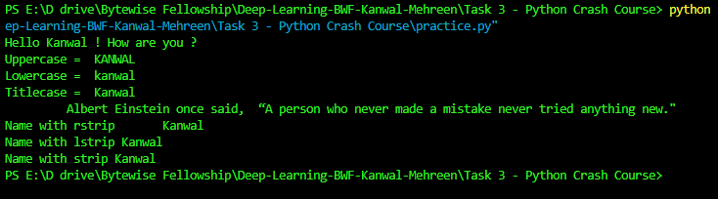

**Numbers**

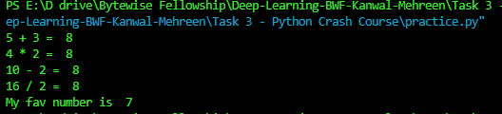

**Comments**



1. **Introducing Lists**

**Accessing elements in List**

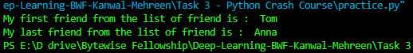

**Changing and Adding Elements in List**

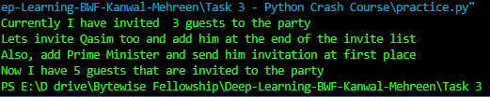

**Sorting List**



1. **Working with Lists**

**Looping through List**

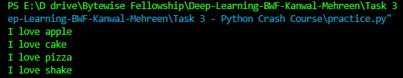

**List Comprehension and Numerical Lists**



**Working with Parts of Lists**



**Nested Loops**

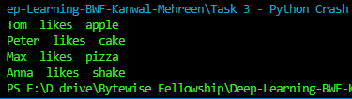

**Tuples**

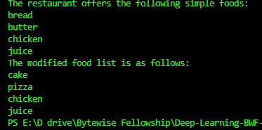

**Styling Code**

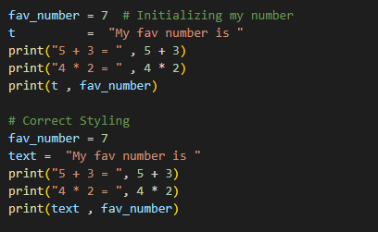

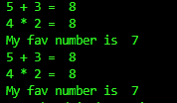

* Removed the unnecessary comment.
* Added the meaningful variable names.
* Removed extra space before the comma within print statements and space around an assignment (or other) operator to align it with another